SCHOOL INTERVIEW/DISCUSSION GUIDE

Name of school: IKUMBYA SEED SECONDARY SCHOOL

1a | Does the Facility have a record of all assets provided under UgIFT.  (Obtain a record and verify if it has the costs and numbers supplied | - YES
1b | If Not ask how many were supplied and when.

2 | How does this facility Maintain (repair/service/replace) the assets provided under Ugift  - It is maintained by the facility officials in charge using part of the PTA and Capitation grant to work on minor repair, service and replacement.

3 | Does the facility take regular record about functionality/ or breakdown of the assets provided?  Nonfunctional/ working, and reasons for non-functionality. | - Yes  REASONS FOR NON FUNCTIONALITY  - Theft of school property due to lack of a fence  - Unreliable electricity  - Some equipment we received are substandard for examples the shelves, chairs, and desks

- 4 | - How has the UgIFT support helped in service delivery in the area, any issues, challenges and any recommendations for better program implementation. | - HOW UGIFT HAS HELPED.  - ICT integration in teaching and learning, the ICT support received has helped the school to integrate ICT in all subjects, this has made learning easier, more practical and interesting for learners ans teachers.teachers can now integrate their marks on their own.  - Increased access to free education, the USE program has enabled many vulnerable children to access free education and reduce school dropouts.  - Employment and economic impact, the school has created indirect employment for the local community through small scale business, like renting by the staff, selling of scholastic materials and food.  - Improved discipline, cases of drug abuse and idleness among youth have reduced because children are now engaged in school.  - Improved parents support, parents attitude towards education has changed positively. They now attend PTA meetings regularly and support school development structures.  - Improved staffing and infrastructure, the school received new teachers from different regions and some infrastructure maintenance was done.  CHALLENGES  - Inadequate USE and UPULET capitation grant is still very little and cannot cover all school activities and projects.  - Under staffing, the school is understaffed which increases workload and affect syllabus coverage.  - Limited land for projects, the school lacks enough land for income projects yet it is required to have them.  - Inadequate staff accommodation, staff quarters are not enough to accommodate all the the teachers. Some teachers are forced to rent out side the school.  - Lack of power in the staff quarters hence affecting the staff welfare and security.  - Theft and security, the school registered cases of ICT equipment from the lab.  - Uninstalled ICT equipment, some of the ICT equipment delivered on 4th/6/2021 including CCTV camera and server are not yet installed, engineers did not complete the work.  RECOMMADATION  - Ministry through district should increase USE fund to match enrollment.  - The district should help the school acquire more land for projects and school field.  - Ministry should consider construction of more staff quarters and connect power to them.

PROCEED TO VERIFICATION AFTER THIS DISCUSSION

SCHOOL FURNITURE
(School Desks, Office chairs, Laboratory stools, Book shelves)

Name of LG LUUKA DISTRICT LOCAL GOVERNMENT Name of SCHOOL IKUMBYA SEED SECONDARY SCHOOL
Equipment/ Item | Department | Item  Description | Life in Months | Tag Number ( engrave no.) | Date Of Pur | Date Placed In Service | Recoverable cost | Cost | Acc Dep Cost | Net Book Value | Ytd Deprn | Equipment status | Remarks
School 3 seater  Desks, | education | Long Brown wooden with black metallic stands and a shelve for books |  | engraved  IKUMBYA  SSS UGIFT  2018 /19 |  |  |  |  |  |  |  | Good and in use | 120recceived  verified as good
Office Chairs | Education | Coffee brown soft seatr with 4 metallic black stands |  | engraved  IKUMBYA  SSS UGIFT  2018 /19 |  |  |  |  |  |  |  | functioning | 20received  verified as good  2 faulty.
Laboratory stools | Education | Round wooden hard seat with 4 black metallic stands |  | engraved  IKUMBYA  SSS UGIFT  2018 /19 |  |  |  |  |  |  |  | Good and in use  But some broken | 192received  verified and in good use.  9 broken
Book shelves | education | Wooden in nature, wall mounted with gray metals while others are built on the wall with compatibles |  | engraved  IKUMBYA  SSS UGIFT  2018 /19 |  |  |  |  |  |  |  | Good condition | 10shelves places in different blocks  verified
Leaners  Chair | education | Brown single sitter square woolen chair with 4 metallic |  | engraved  IKUMBYA  SSS UGIFT  2018 /19 |  |  |  |  |  |  |  | Most of them in  good condition  Very few damaged  and not in use | All 278  Verified as good  In use and 24  broken
drawers | education | Vertical wall cupboard built the the behind corner of the classroo |  | engraved  IKUMBYA  SSS UGIFT  2018 /19 |  |  |  |  |  |  |  | Good condition  And  functional | 6 built with each classroom one built and verified.
learners  table | education | Wide wooden brown table with metalic stands |  | engraved  IKUMBYA  SSS UGIFT  2018 /19 |  |  |  |  |  |  |  | Good condition  And  functional | 102 received  Verified  good and in use  2demaged,
office  table | education | Wide wooden brown table with a cabinet |  | engraved  IKUMBYA  SSS UGIFT  2018 /19 |  |  |  |  |  |  |  | Good condition  And  functional | 5 received  Verified  good and in use
ICT ITEMS TO VERIFY
(Desktop Computer, Server Processor, Network Switch 24 Port, Multipurpose Printer, UPS, Projector, Air Conditioners, Server, CCTV Camera)

Name of LG LUUKA DISTRICT LOCAL GOVERNMENT Name of SCHOOL IKUMBYA SEED SECONDARY SCHOOL
Equipment/ Item | Department | Item  Description | Life in Months | Tag Number ( engrave no.) | Date Of Pur | Date Placed In Service | Recoverable cost | Cost | Acc Dep Cost | Net Book Value | Ytd Deprn | Equipment status | Remarks
Desktop Computer | Education | Intel core i5  Processor,  13th  Generation  RAM 8GB,  512SSD,  15 INCH |  | Not engraved |  |  |  |  |  |  |  | Good and  functional | 29received but  12verified,10 stolen.  2 faulty.
Server Processor | education |  |  | Not engraved |  |  |  |  |  |  |  | Good and  functional | 1 received but  not verified,
Network Switch 24 Port | education | CORE L2  SWITCH  L3 IRU CHASSIS |  | Not engraved |  |  |  |  |  |  |  | Good and  functional | 1 received  verified
Multipurpose Printer | education | A4,LASER  33PPM  MINIMUM  1200*1200 |  | Not engraved |  |  |  |  |  |  |  | Good and  functional | 1 received  verified,
UPS | education | AT LEAST  750VA  SWING AC  196-280V  50-60HZ |  | Not engraved |  |  |  |  |  |  |  | Good and  functional | received  5 verified,
Projector | education | 3LCD/DLP/  LED  TENONOLOGY |  | Not engraved |  |  |  |  |  |  |  | Good and  functional | 1 received  verified
Air Conditioners | education |  |  | Not engraved |  |  |  |  |  |  |  | Good and  functional | 1received  verified
Server | education | 12TH  GENERATION  DVD-ROM  9.5MM ODD |  | Not engraved |  |  |  |  |  |  |  | Good and  functional | 1 eceived but  verified
CCTV Camera | education | 4MP  UP TO 30  IMAGES PER  SECOND |  | Not engraved |  |  |  |  |  |  |  | Good and  functional | 1 eceived  verified
firewall | education | VPN(SSL VPN  &IPSee) |  | Not engraved |  |  |  |  |  |  |  | Good and  functional | 1received  verified,
wireless  router | education | 2.4GHZ  5.0GHZ |  | Not engraved |  |  |  |  |  |  |  | Good and  functional | 1received  verified
LAN

BUILDINGS TO VERIFY
(Non- Residential and Residential, Kitchen, Toilets/Pit latrine Water tanks, Fences etc.)

Name of LGLUUKA DISTRICT LOCAL GOVERNMENT Name of SCHOOLIKUMBYA SEED SECONDARY SCHOOL
Equipment/ Item | Department |  | Item  Description | Life in Months | Tag Number ( engrave no.) | Date Of Pur | Date Placed In Service | Recoverable cost | Cost | Acc Dep Cost | Net Book Value | Ytd Deprn | Equipment status | Remarks
Classroom block | education |  | Coffee brown and yellow in color with white glasses and ventilators and a lightening conductor on top of the roof |  | Not engraved |  |  |  |  |  |  |  | All functioning | The following were verified.  3 classroom blocks with two partitions each.  1 main hall.  1 computer lab.  1 administration block  1 science lab
Fence | education |  |  |  |  |  |  |  |  |  |  |  | Not yet built | Not verified
latrines | education |  | Colored coffee brown with a private wall with 5 stances |  | Not engraved |  |  |  |  |  |  |  | functioning | 6 seen verified.  1 for boys.  1 for girls.  1 for staff.
Water tanks | education |  | Black in color, cylindrical in nature, put on the raised base |  | Not engraved |  |  |  |  |  |  |  | All functioning | 2 were verified.  1 on the administration block  1 on the lab.  1 on the classroom block
Kitchen Block | education |  | Coffee brown and yellow in color with a smoke outlet |  | Not engraved |  |  |  |  |  |  |  | Not yet buil | Not verified
Lightening conductor | Education |  | Metallic in nature, put on top of the roof running downwards to the ground |  | Not engraved |  |  |  |  |  |  |  | functioning | Counted and verified 14
staff  quarters |  |  | Coffee brown and yellow in color with each 4units |  | Not engraved |  |  |  |  |  |  |  | Good condition and functional | 3 received,  verified  In use
staff  kitchen |  |  | Coffee brown and yellow in color with a smoke outlet and 2 uits |  | Not engraved |  |  |  |  |  |  |  | Good condition and functional | 3 received,  verified  In use
staff  latrines |  |  | Colored coffee brown with a private wall with 2 stances and 2 bathrooms. |  | Not engraved |  |  |  |  |  |  |  | Good condition and functional | 1 received and verified, in use
staff  water  tank |  |  | Black in color, cylindrical in nature, put on the raised base |  | Not engraved |  |  |  |  |  |  |  | Good condition and functional | 1 received and verified, in use

ASSET VERIFICATION BRIEF REPORT
IKUMBYA SEED SECONDARY SCHOOL

DATE 27TH/8/2026.

CONDUCTED BY WANDERA SOLOMON AND KIYUBA SALIMU

Introduction.
This brief report presents the findings of the physical asset verification exercise conducted at ikumbya seed secondary school on 27TH/8/2026. The team was warmly welcomed by respondent, the depute headmistress who was the focal person in this exercise .

Findings.
- Key assets including all furniture and buildings were physically verified and found present. However, the computer laboratory was verified with claims that some of the ICT equipment were stolen and case was reported said the depute headmistress who was the focal person in this verification exercise . All the items were found to be functional and in good physical condition.
- Limited infrastructure. The facility is facing a challenge of inadequate facilities for studies. This has led to congestion, during UNEB we rent tents to accommodate the senior ones and twos said depute headmistress
- The facility has inadequate accommodation for staff. The available staff quarters are not sufficient to accommodate all the critical staff required to be within the facility premises especially the principals.
- The facility lack non staffing such as library attendant, cleaners, cooks and also the facility lacks a fence hence hence making liable to theft.

Challenges.
- Almost all the assets were not engraved thus making the verification exercise very hard because we could not establish whether what we verified was for Gift of not.
- Some offices including administration and computer lab were inaccessible at the time of visit due to lack of keys since the keepers were not available at the time of verification.
- The district failed to give us the asset register and the DEO only provided for ICT, therefore, we only relied on the physical counting.

Recommendation.
- Management should provide a police report or an official document for the reported theft of the ICT lab for accountability. The ministry through the district should consider re equipping the computer laboratory and strengthening security
- The ministry through the district should prioritize at expanding classroom or infrastructure to reduce congestion. Temporary renting of tents during UNEB should be addressed by constructing more examination halls.
- Limit the supply of many equipment and ensure needs based supply.the supply of equipment should be based on facility needs assessment and capacity.
- Immediate engraving of assets should be done immediately upon receipt with source of funding and asset codes for easy identification during verification.
- On staffing and security, the ministry through the district should recruit more teaching , non teaching to ensure effective and quality education.
- The district and DEO should always maintain and provide an update asset register during the verification.
- Ministry through the district should consider construction of more staff quarters to accommodate and retain critical staff for effective teaching.

Conclusion.
The asset verification exercise was successfully completed with full staff from depute headmistress. All critical assets were verified, are functional, in good condition and well handled apart from a very few cases of broken furniture.
Addressing non teaching staff and staff accommodation, fence and kitchen challenges will greatly improve on the quality , efficiency and asset management.
Annex

Sample of Physical Verification Pictures.

The table below illustrates some physical status of the verified assets with photographic evidence.
Table XXX: Physical verification photos
IKUMBYA SEED SECONDARY SCHOOL | 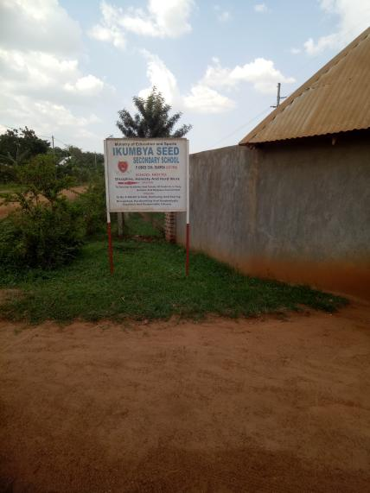

IKUMBYA SEED SECONDARY SCHOOL  OFFICE CHAIRS | 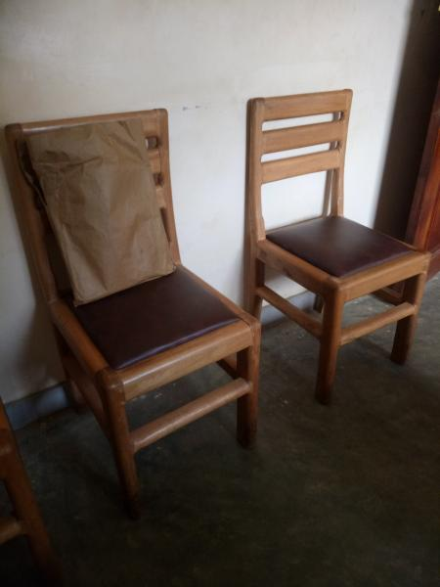
IKUMBYA SEED SECONDARY SCHOOL  STORED ICT ITEMS NOT INSTALLED,  MULTI PURPOSE  PRINTER. | 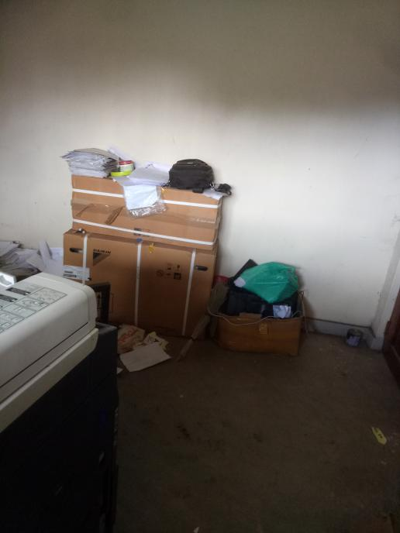
IKUMBYA SEED SECONDARY SCHOOL  OFFICE TABLE | 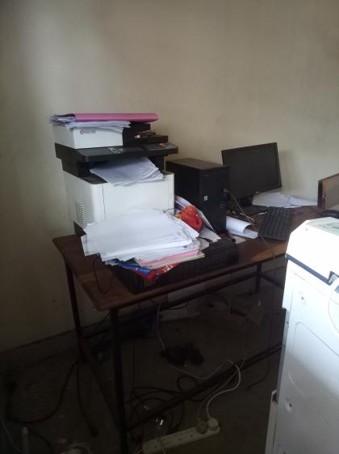

IKUMBYA SEED SECONDARY SCHOOL  OFFICE TABLE | 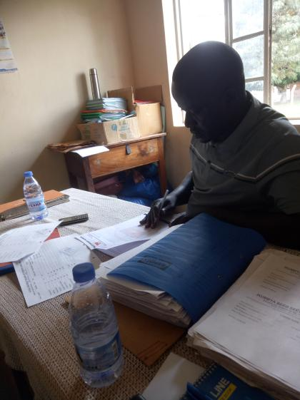

IKUMBYA SEED SECONDARY SCHOOL  SCHOOL BLOCKS | 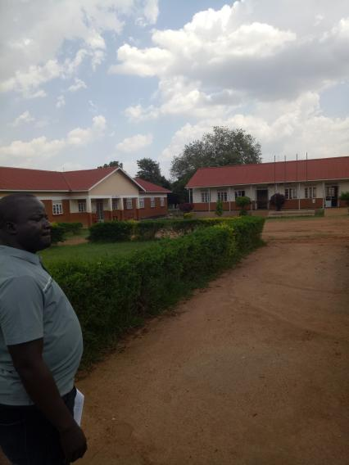

IKUMBYA SEED SECONDARY SCHOOL  SCHOOL BLOCKS | 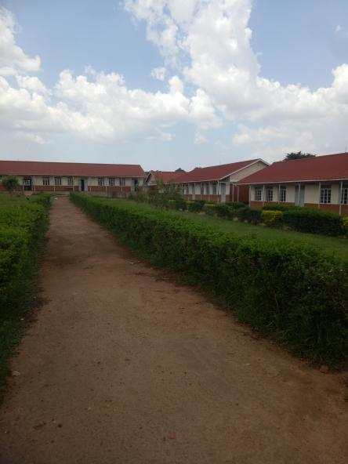
IKUMBYA SEED SECONDARY SCHOOL  BOOK SELVES | 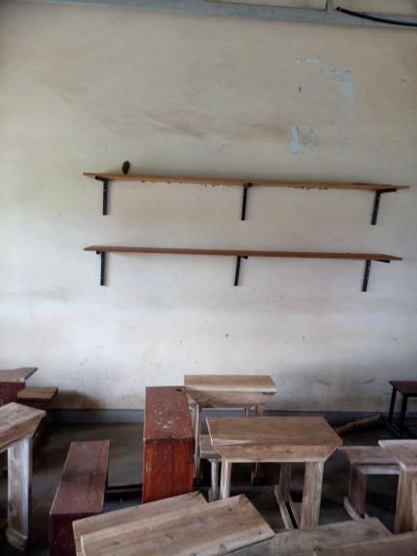
IKUMBYA SEED SECONDARY SCHOOL  STAFF TOILETS | 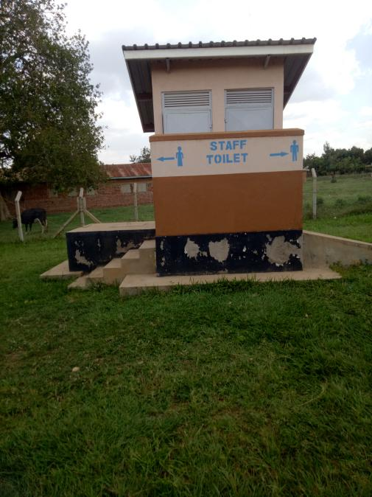
IKUMBYA SEED SECONDARY SCHOOL  BROKEN SELF | 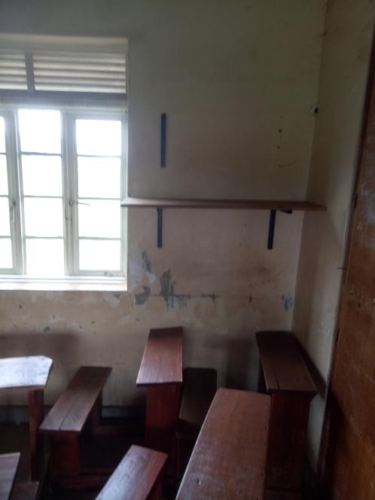
IKUMBYA SEED SECONDARY SCHOOL  WALL BULT DRAWER/CUPBOARD | 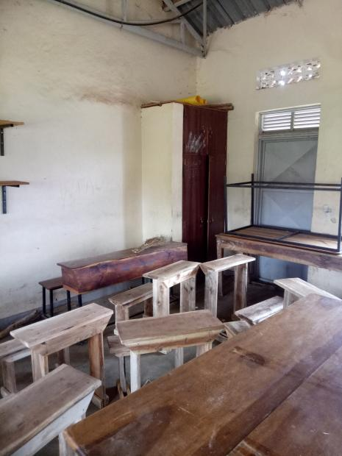
IKUMBYA SEED SECONDARY SCHOOL  ENGRAVED DESKS. | 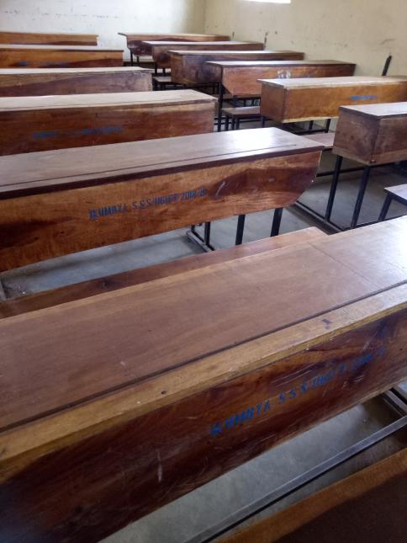
IKUMBYA SEED SECONDARY SCHOOL  COMPUTER LAB  WITH TBLES AND  STOOLS. | 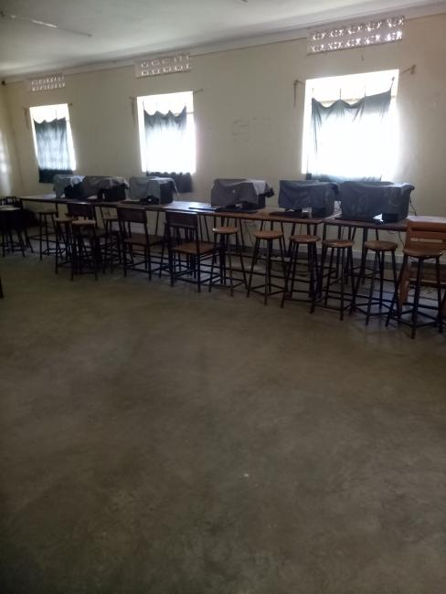
IKUMBYA SEED SECONDARY SCHOOL  COMPUTER LAB  WITH TBLES AND  STOOLS. | 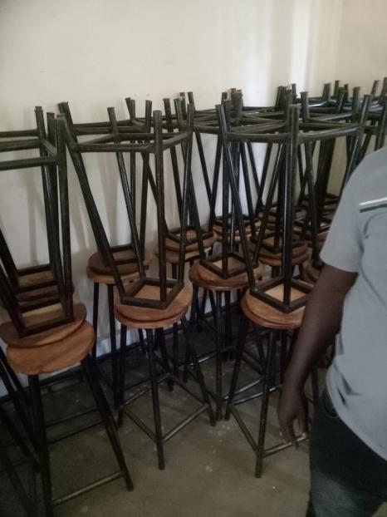
IKUMBYA SEED SECONDARY SCHOOL  Network Switch 24 Port | 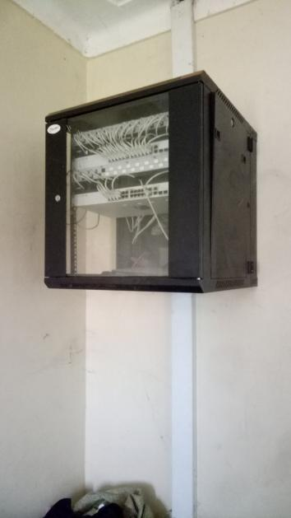
IKUMBYA SEED SECONDARY SCHOOL  COMPUTER LAB WITH  UPS. | 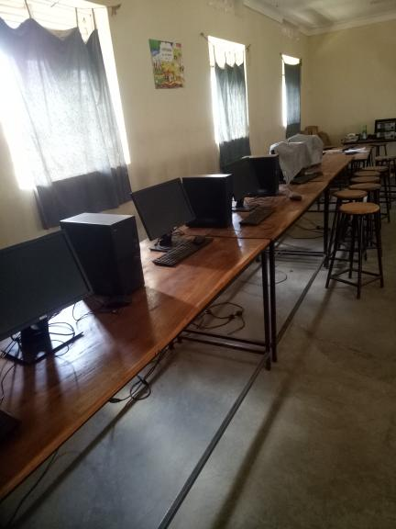
IKUMBYA SEED SECONDARY SCHOOL  WINDOW LOBBERS USED | 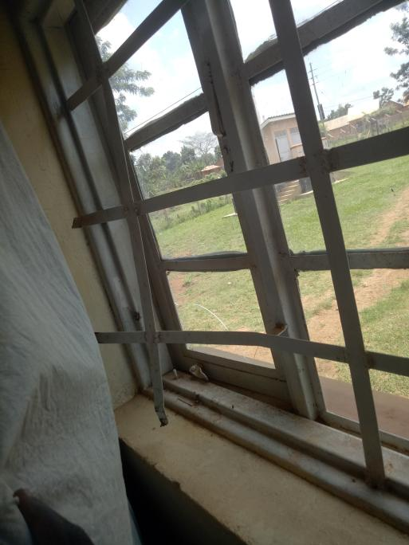
IKUMBYA SEED SECONDARY SCHOOL  BOOKSELVES | 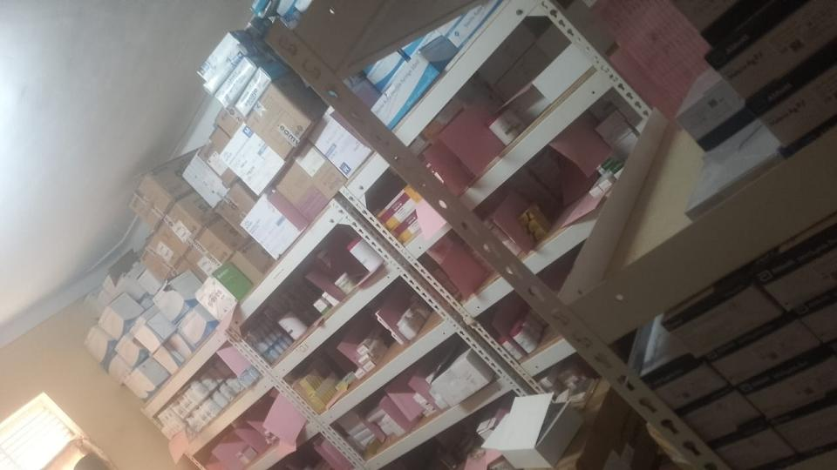
IKUMBYA SEED SECONDARY SCHOOL  STAFF QUARTER WITH  KITCKEN | 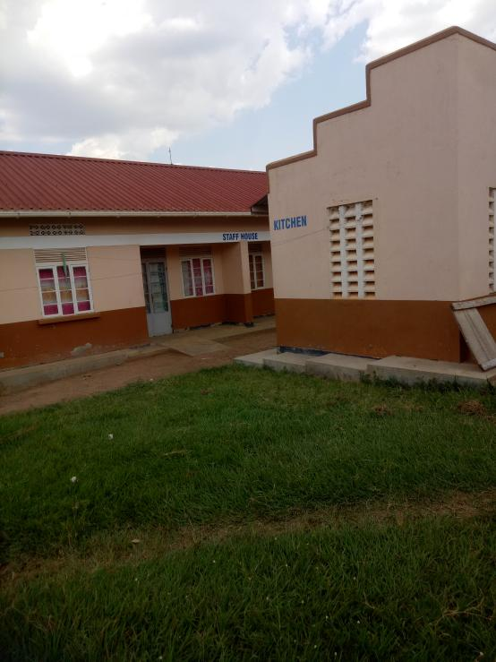
IKUMBYA SEED SECONDARY SCHOOL | 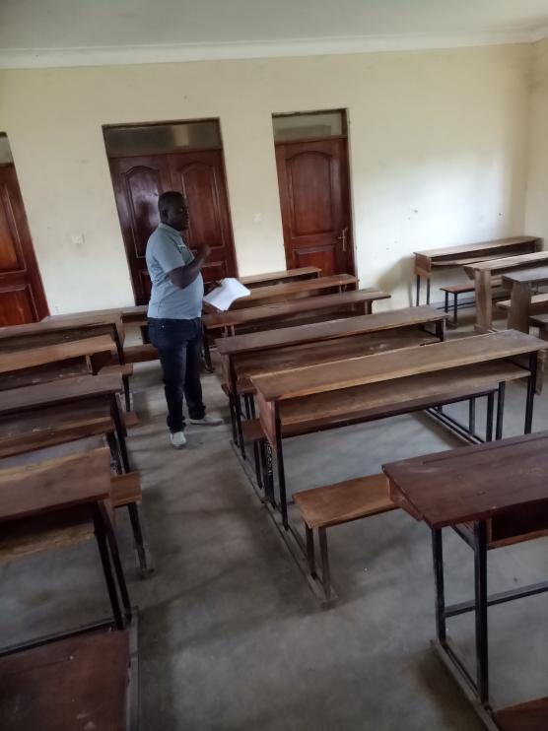
IKUMBYA SEED SECONDARY SCHOOL  KITCKEN | 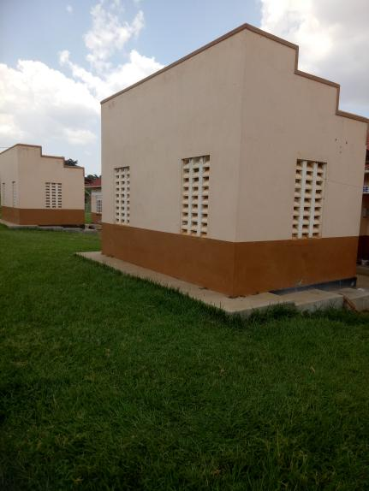
IKUMBYA SEED SECONDARY SCHOOL  LAB | 